Wireshark Lab 1-1

202022300317 杨业昶

## 1. List 3 different protocols that appear in the protocol column in the unfiltered packet-listing window in step 7 above.

TCP

TLS v1.2

DCHPv6

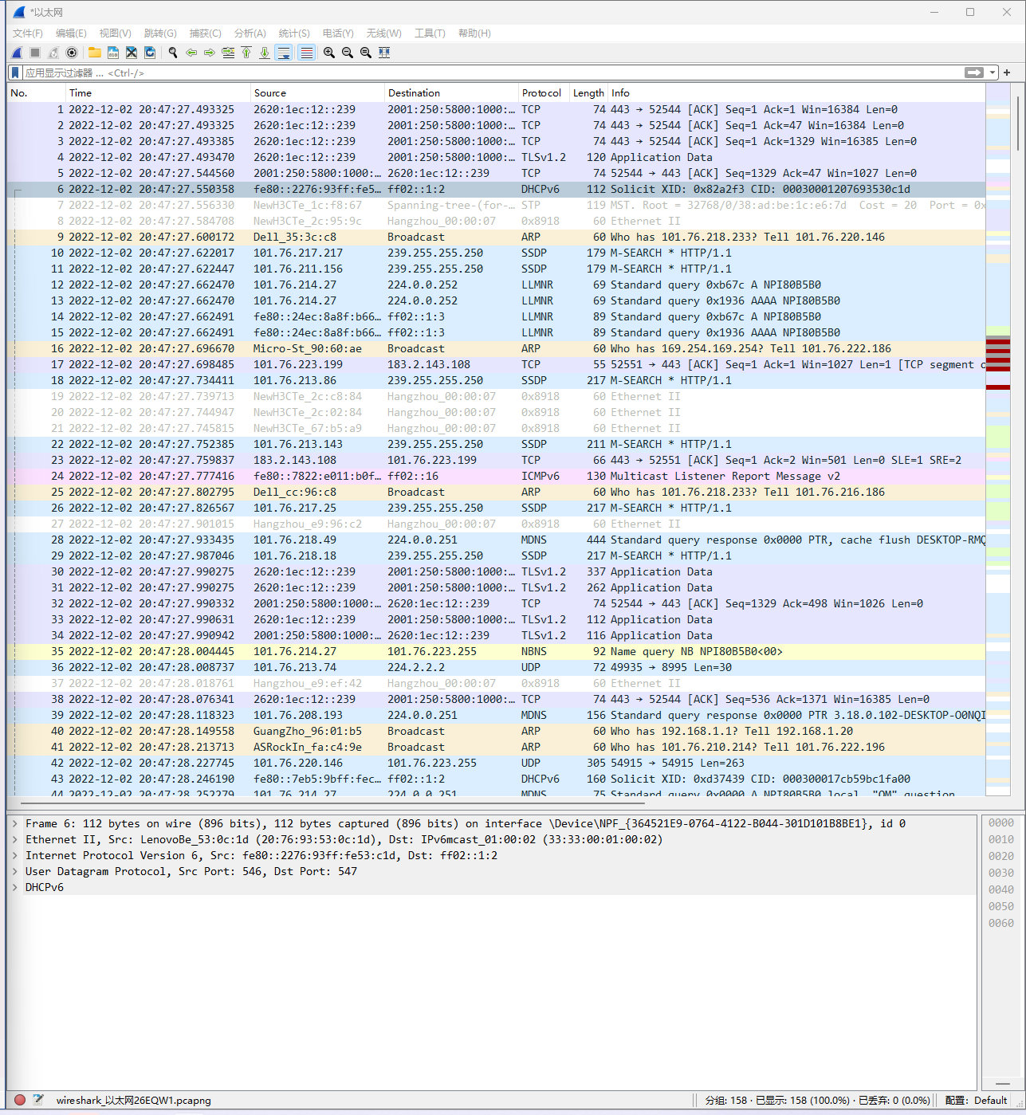

## 2. How long did it take from when the HTTP GET message was sent until the HTTP OK reply was received?

0.246944s

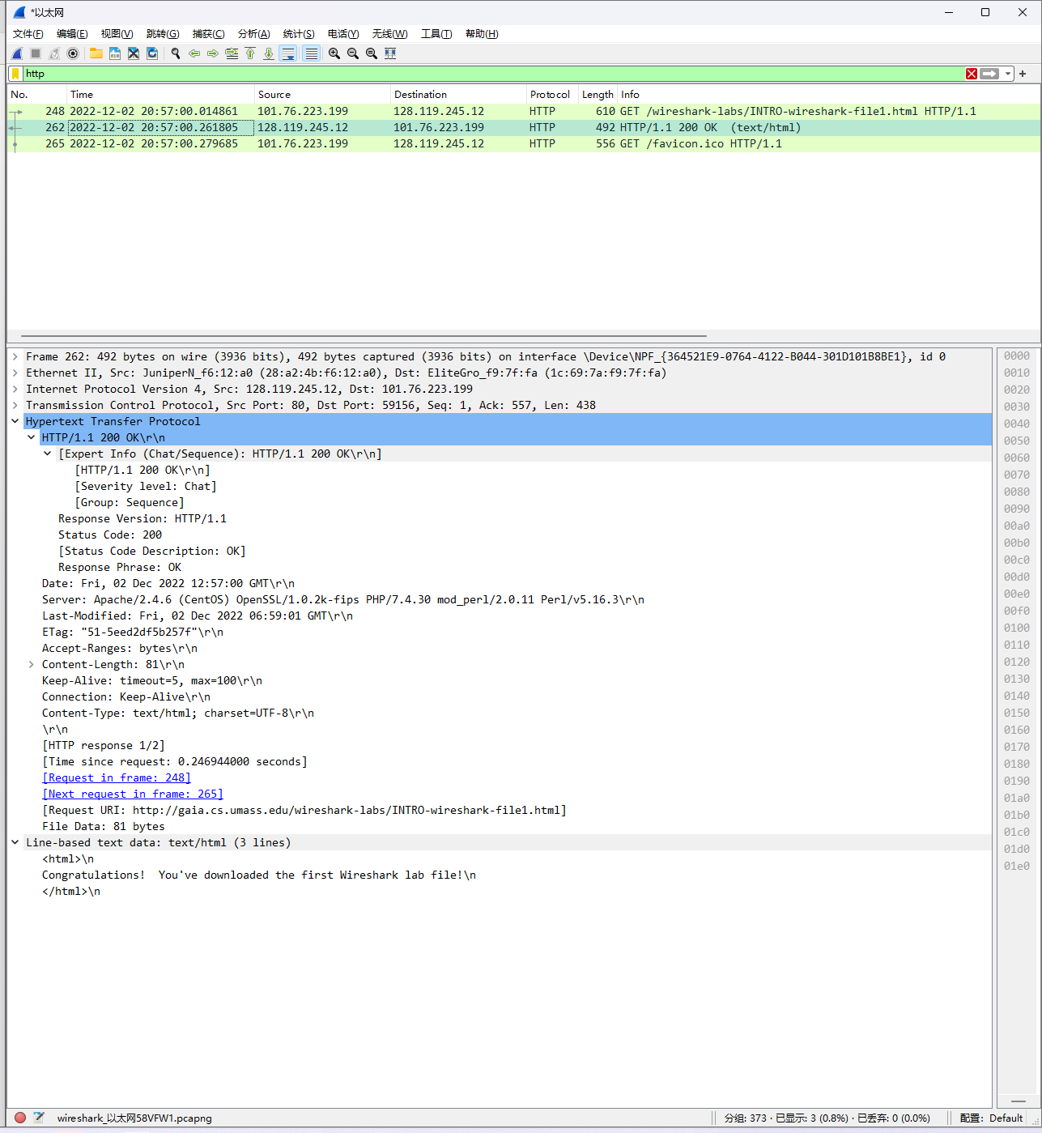

## 3. What is the Internet address of the gaia.cs.umass.edu? What is the Internet address of your computer?

128.119.245.12

101.76.223.199

## 4. Print the two HTTP messages (GET and OK) referred to in question 2 above.

